MP Online Limited
Project Report
Digital Grievance Redressal System

Organization: Jawaharlal Institute of technology Borawan
Prepared By: Neha Rathod
Enrollment no. :0403AL221042
Date: May 2026
Digital Grievance Redressal System
1. Introduction
1.1 Purpose
The Digital Grievance Redressal System is a web-based application developed to provide a transparent and efficient platform for citizens to register complaints and track their resolution status. The system digitizes the complaint management process and improves communication between citizens and administrators.
1.2 Problem Statement
Traditional complaint management systems rely heavily on manual processes, resulting in delays, lack of transparency, and inefficient tracking of complaints. Citizens often face difficulties in knowing the progress of their submitted complaints. The proposed system provides a centralized digital solution to address these issues.
1.3 Objectives
- Provide an online platform for complaint registration.
- Enable users to track complaint status.
- Allow administrators to manage complaints efficiently.
- Support image uploads as evidence.
- Improve transparency and accountability.
- Maintain digital records of all complaints.

2. Technology Stack
Layer | Technology | Purpose
Frontend | React JS | User Interface Development
Styling | Tailwind CSS, CSS3 | Responsive and Modern UI Design
Animation | Framer Motion | Interactive User Experience
Routing | React Router DOM | Navigation Between Pages
Backend | FastAPI (Python) | REST API Development
Database | SQLite | Relational Database
Authentication | JWT | Secure Login and Authorization
Password Security | Passlib (bcrypt) | Password Encryption
File Upload | Python Multipart | Handling Image Uploads
API Communication | Fetch API | Frontend-Backend Communication
Version Control | Git & GitHub | Source Code Management
IDE | Visual Studio Code | Development Environment

3. System Architecture
The system follows a three-tier architecture:
Presentation Layer
- React JS
- Tailwind CSS
- Framer Motion

Application Layer
- FastAPI
- JWT Authentication
- Business Logic
Data Layer
- Database
SQLite Data Flow
User → React (Frontend UI)
↓
FastAPI (Backend API Layer)
↓
SQLite Database (Storage Layer)

4. Database Design
4.1 Users Collection
Field Name | Type | Description
_id | Integer (Primary Key) | Unique user identifier
name | String | User full name
email | String | User email
password | String | Encrypted password
role | String | User role
Phone | Number | Mobile number

4.2 Complaints Collection

Field | Type
id | Integer
title | String
category | String
description | Text
address | String
landmark | String
images | String / separate table
user_id | Integer (Foreign Key)
status | String
admin_remark | String
created_at | DateTime
updated_at | DateTime

5. Features Implemented
User Features
- User Registration
- Secure Login using JWT
- Multi-step Complaint Submission Form
- Complaint Categorization
- Location Details Submission
- Image Upload Support
- Complaint Status Tracking
- Responsive User Dashboard
Admin Features
- View All Complaints
- Update Complaint Status
- Manage User Complaints
- Add Administrative Remarks
- Complaint Monitoring Dashboard

6. Complaint Categories
- Water Supply
- Electricity
- Gas Leakage
- Drainage / Sewage
- Road Damage / Potholes
- Street Lighting
- Traffic Signal Issue
- Public Transport Issue
- Garbage Collection
- Public Toilet Issue
- Sanitation Problem
- Park Maintenance
- Encroachment
- Other

7. File Upload System
- Images are uploaded using FastAPI Multipart Upload
- Stored in server directory or cloud storage
- File paths saved in database

8. Security Features
- JWT Based Authentication
- Password Hashing using bcrypt
- Protected API Routes
- Role-Based Access Control
- Secure File Upload Handling

9. Challenges Faced
Challenge | Solution
JWT Authentication Errors | Implemented proper token validation
File Upload Handling | Used FormData and Multipart Support
Frontend-Backend Communication | Configured CORS Middleware
Complaint Image Preview | Implemented React Preview Components
SQLite Data Management | Structured Collections and CRUD APIs

11. Snapshots
1. RegisterPage:-
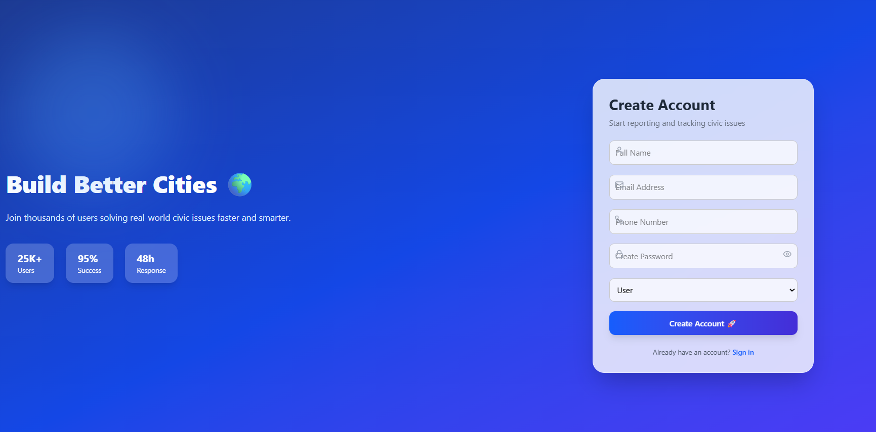

2. LoginPage:-
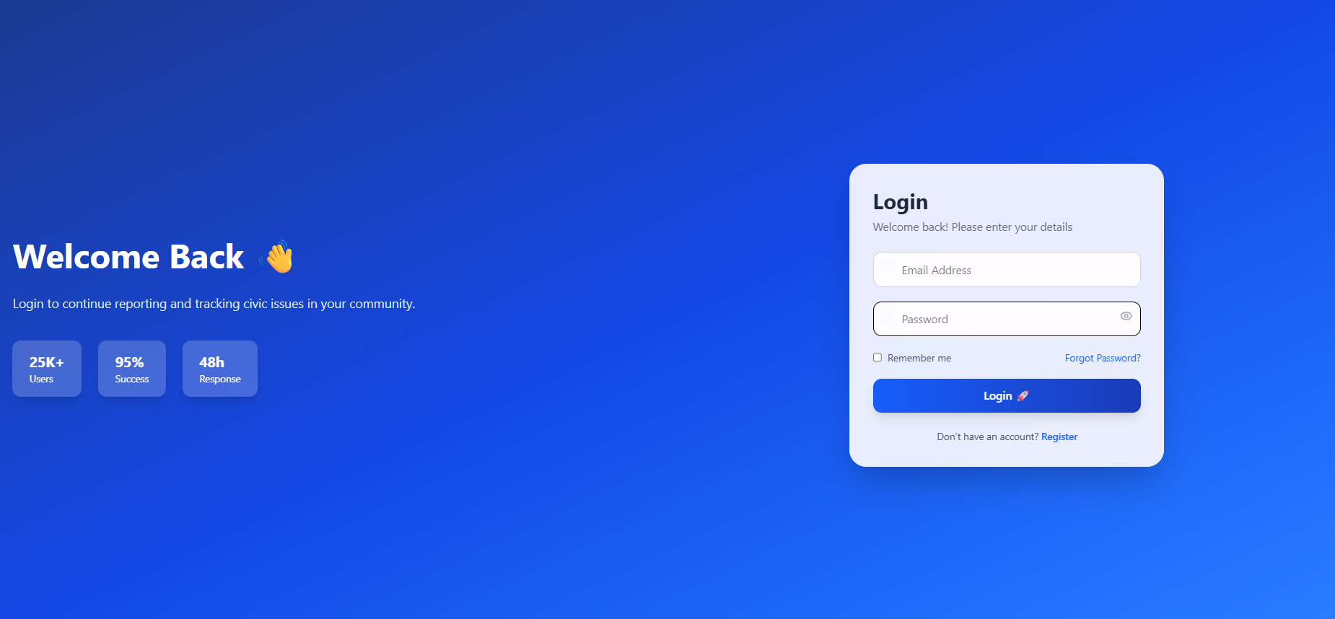

3. User Dashboard :-
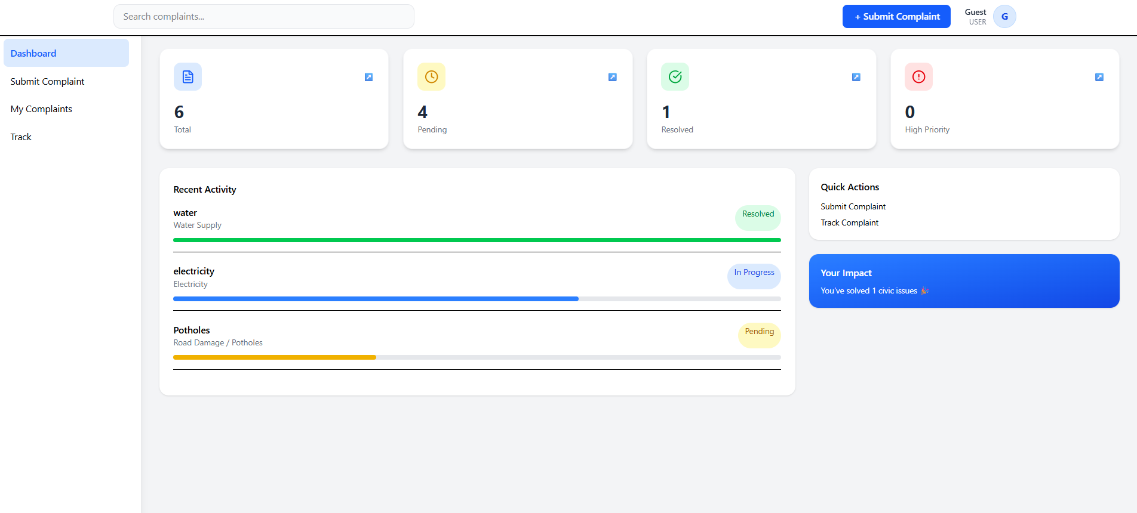

4. MyComplaint:-
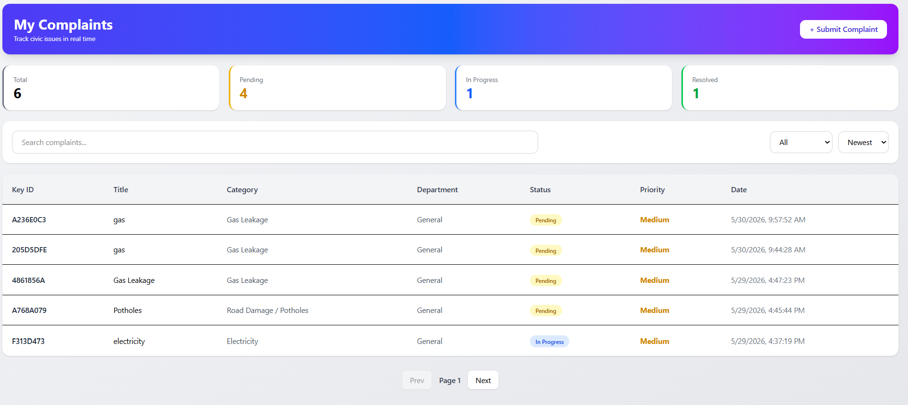

5. Track Ticket :-
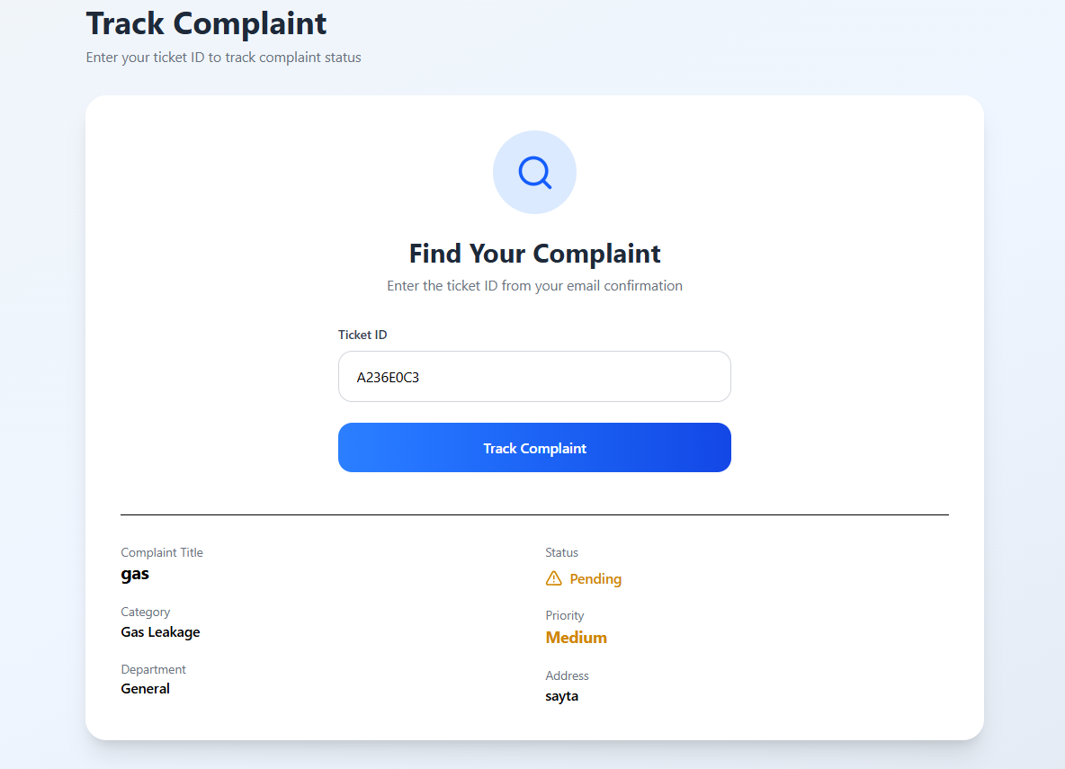

6. Admin Dashboard :-
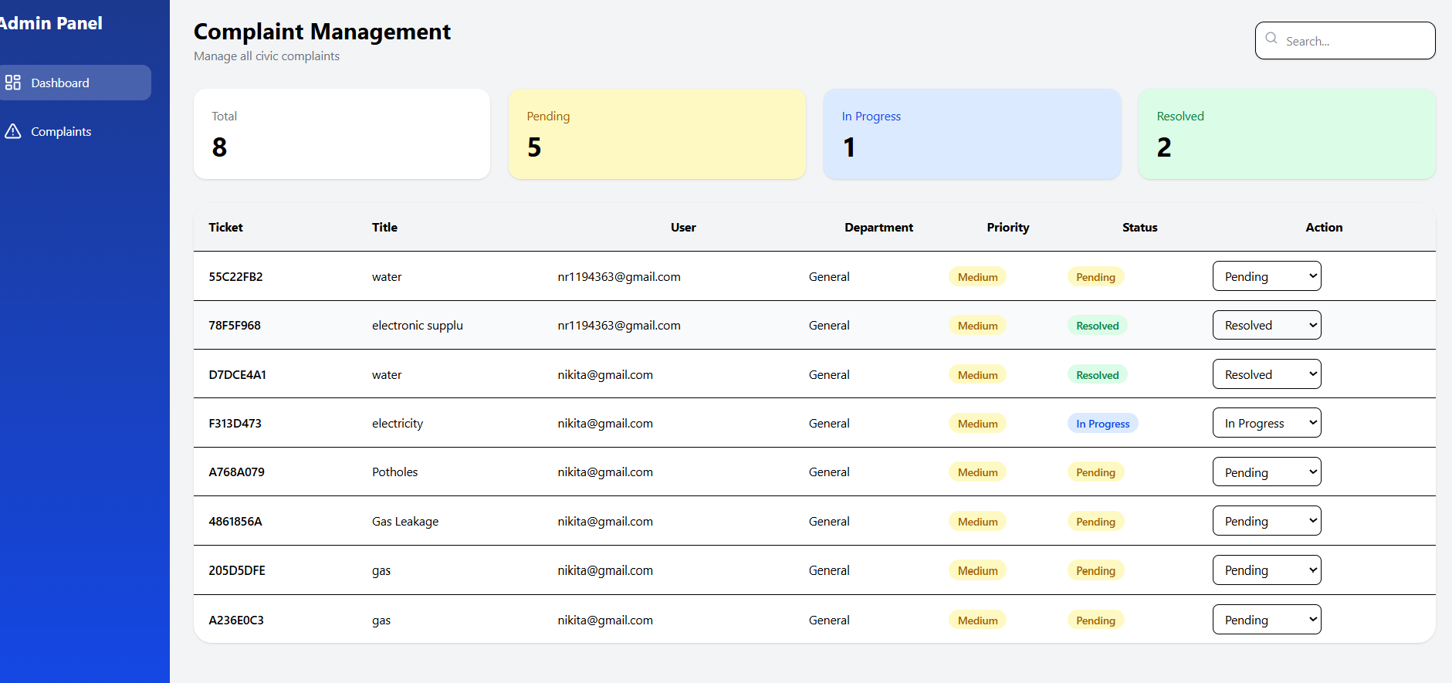

12. Vedio Upload On Google Drive :-
https://drive.google.com/file/d/18qj0trcbdHJ3-JHAZx2YtoT6apvRAIX4/view

13. Conclusion
The Digital Grievance Redressal System successfully provides a digital platform for registering and managing public complaints. The application improves transparency, accountability, and efficiency by enabling users to submit complaints online and monitor their status. The integration of React, FastAPI, MongoDB, and JWT ensures a secure, scalable, and user-friendly solution.

14. Future Scope
- Email Notifications
- SMS Alerts
- Mobile Application
- AI-based Complaint Categorization
- Multi-language Support
- Advanced Analytics Dashboard
- Complaint Priority Prediction
- Geo-location Based Complaint Tracking

